EUIPO’s new building wins top environmental award

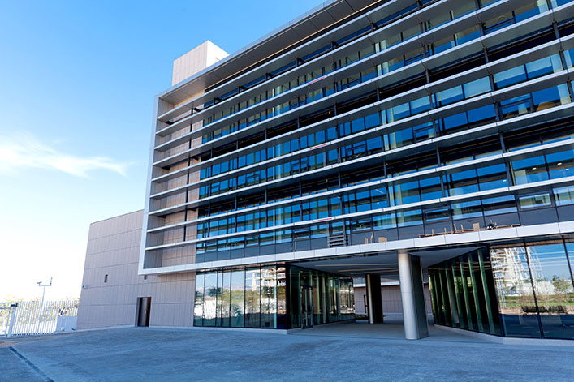

The EUIPO has won the gold award at the Green Apple Environment Awards in the “Built Environment & Architectural Heritage” category for its AA3 Building.

The award was announced at a ceremony organised by the Green Organisation on 22 July in London. This is the third such recognition obtained by the Office from the [Green Organisation](http://www.thegreenorganisation.info/homepage/), after receiving one gold and one bronze award in 2016.

The Green Organisation was established in 1994 as 'an international, independent, non-profit, non-political, non-activist environment group, dedicated to recognising, rewarding and promoting environmental best practice around the world.'

The Awards scheme was set up to recognise, reward and promote environmental best practices worldwide. Amongst the aims of the awards are the improvement of environmental performance, encouraging the efficient use of resources and supporting sustainable development, including social benefits through community and staff involvement.